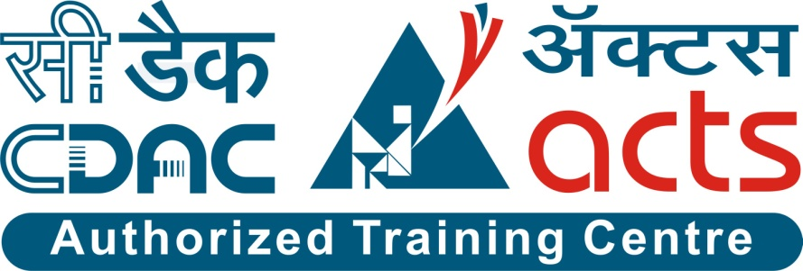

Project Name: FOODIES-HUNT An Online Mess Service Portal PG - DAC Sept- 2021.

Documentation On

**“FOODIES HUNT A ONLINE MESS SERVICE PORTAL”**

PG - DAC Sept 2021

**Guided By: Monika Shivankar**

Submitted By :

**Group No: 22**

* **Mitesh Kulkarni 210943020041**
* **Mahesh Shewale 210943020047**
* **Vallabh Khirolkar 210943020106**
* **Onkar Yadav 210943020111**

**Table of Contents**

**1. Introduction 4**

1.1 Document Purpose **4**

1.2 Project Background **4**

1.3 Aim & Objectives **4**

**2. Business Requirements Overview**…………………………………………………………**5**

**3.Functional Requirements** **5**

3.1 Consumer Module **5**

3.2 Mess Owner Module **6**

3.3 Admin Module **6**

**4.** **Non-Functional Requirement………………………………………………………………6**

**5. Use Case Diagram 7**

5.1 Admin **7**

5.2 Consumer **8**

5.3 Mess Owner **9**

**6. Database Design 10**

1 Consumer **10**

2 Mess Owner **10**

3 Login…………………………………………………………………………………… **10**

4 Mess **11**

5 Veg Menu **11**

6 Non Veg Menu **12**

7 Review **12**

**7. E-R Diagram………………………………………………………………………………………13**

**8. Snapshots 14**

**9. Conclusion 25**

**List of Figures**

**Use Case Diagrams 7**

Fig 1 Admin 7

Fig 2 Consumer 8

Fig 3 Mess Owner 9

Fig 4 ER Diagram 12

1. **Introduction:**
   1. **Document Purpose:**

This document explains the system requirements and scope for developing Online Mess Service System.

Online Mess Service System could divide the three main parts i.e. Consumer part, Mess Owner part and Admin part.

## Project Background:

Currently there is no online portal for Mess Owners to convey their daily menu to their Consumers on regular basis. Currently, the consumers wander messes to messes as per their taste of interest, so there is no any such platform available to view daily menu and favorite dishes. There is no discount, coupons management system. Consumers are not able to locate messes nearby area, and according to their cravings. There is no way for Mess Owners to know about daily consumers will he be expecting and the count of special dishes, resulting in food wastage. There is no communication between Mess Owners and their Consumers. No facility is present for the consumers to know the rates at different messes, ratings reviews, feedback where they can make choice of best places to eat.

## Aim & Objectives:

* The main objective of this project is building a platform which will help bachelors, students from various cities to communicate with various Mess Owners and to ease their searching efforts.
* Ensuring the consumer health and safety by providing well hygienic food from register messes.
* Increases business scope for mess service providers.
* Mess Service System provides menus to consumers on daily basis which reduces their time for searching out.

1. **Business Requirements Overview:**

* Mess Service System is the public web application.
* Mess Service System will be opened to the global, but in the phase 1, the main target is in the Pune, India.
* There are mainly two types of users. One is the Mess Owner and other is consumer.
* Consumers can view for mess menus, special dishes as per their convenience.
* Mess Owners can view their registered consumers available and even taste of interest.
* Mess Service System provides the functions which connect the consumers and the Mess Owners efficiently.
* Mess Service System could be maintained by Administrator.

Mess Service System provides such functionalities which connect Consumer and Mess Owner with each other efficiently and it will reduce gap between Consumer and Mess Owner.

# Functional Requirements Overview:

Online Mess Service System consists of three modules described as below.

1. Consumer Module
2. Mess Owner Module
3. Admin Module

# **3.1 Consumer Module**

* Consumer can register and create his own account.
* Online Portal System provides the function which allows consumer to choose messes as per their taste of interest.
* Consumer is able to provide ratings and reviews for that particular registered mess.
* Consumer is able to view their daily menus, rates, special dishes and special offers for the day.
* Consumer can compare various messes according to their taste of interest.
* Consumer is able to view all available messes and their related information.

# **Mess Owner Module**

* Mess Owner can register and create his own account.
* Online Portal provides the function which allows mess owners (user) to add their daily menus.
* Mess Owner able to see ratings and feedbacks given by consumers.
* Mess Owners can provide special menu for the day occasionally.
* Mess owners has to get approval from admin to display mess information.
* Mess Owners can see their registered consumer list.

# **3.3 Admin Module**

* Online Portal provide all function to admin how to handle the System
* Admin has to approve request of Mess Owners.
* Admin can see the Mess Owner and menu details and also if admin found any details in-appropriate, admin can delete those entries.
* Admin can delete previous mess menus.

1. **Non-Functional Requirement:**

* The website should use professional design, look and feel and color scheme.
* Users will have no limitations for accessing the application through Internet. The portal being an internet application, it is difficult specify exact number of visitor or users. Hence, we will target the system to support between 50k and 100k users per city.
* Being a public website, the site must follow general usability guidelines for menus, navigation, colors, links and other actions provided on the screens.
* The system should be designed in such a manner that user will be able to complete tasks in minimum number of steps.
* Identification must be preserved by login id and password.
* Guest will have certain limitation for accessing site.
* Hate speech and abusive comment must be filtered out in comments and review.

## 5. Use-Case Diagram

**5.1 Admin:**

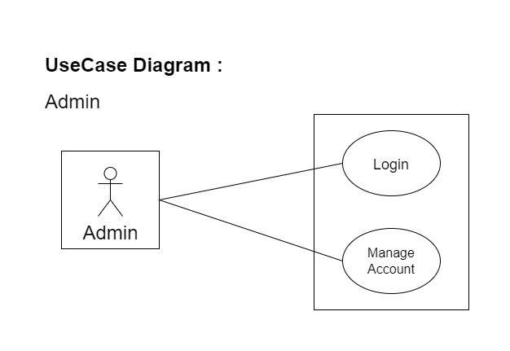

Fig. Use-Case Diagram for Admin

## 5.2 Consumer:

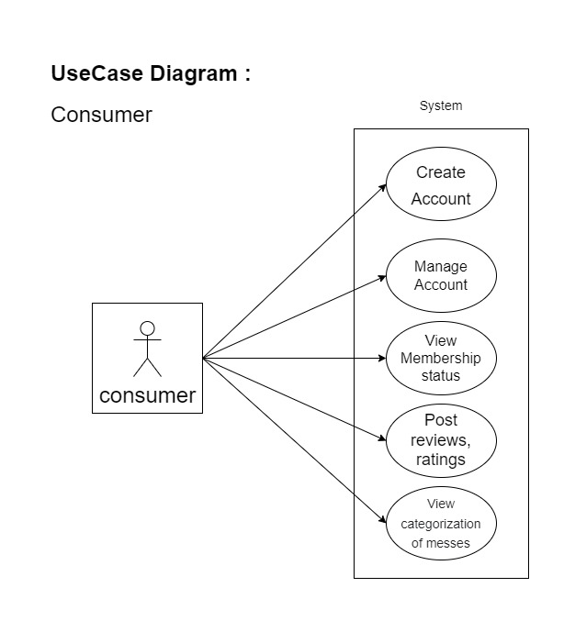

Fig. Use-Case Diagram for Consumer

**5.3 Mess Owner:**

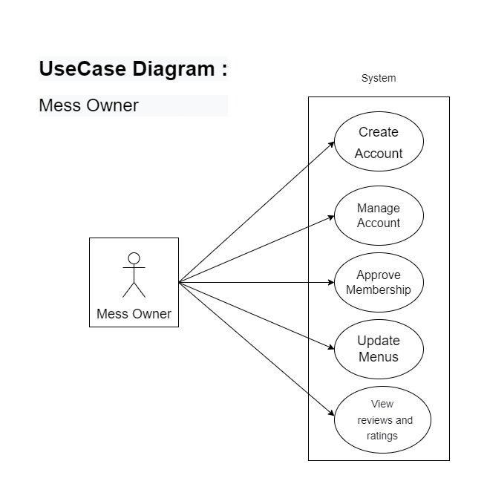

Fig. Use-Case Diagram for Mess Owner

**6. Database Design:**

**1] login table**

|  |  |  |  |  |  |
| --- | --- | --- | --- | --- | --- |
| **Field** | **Type** | **Null** | **Key** | **Default** | **Description** |
| loginid | Integer | No | Primary key | AI | Login ID |
| username | Varchar(45) | No |  |  | User Name |
| password | Varchar(45) | No |  |  | User Password |
| role | Varchar(45) | No |  |  | Consumer, Admin or Mess Owner Role |

**2] Consumer table**

|  |  |  |  |  |  |
| --- | --- | --- | --- | --- | --- |
| **Field** | **Type** | **Null** | **Key** | **Default** | **Description** |
| regid | Integer | No | Primary key | AI | Consumer ID |
| consumername | Varchar(45) | No |  |  | Name |
| mailid | Varchar(45) | No |  |  | Email ID |
| contactno | Integer | No |  |  | Contact No. |
| currentcity | Varchar(100) | No |  |  | CurrentAddress |
| loginid | Integer | No |  |  | Reference to LoginID |

**3] Mess Owner table**

|  |  |  |  |  |  |
| --- | --- | --- | --- | --- | --- |
| **Field** | **Type** | **Null** | **Key** | **Default** | **Description** |
| messid | Integer | No | Primary key | AI | Mess Owner ID |
| approvalstatus | Varchar(45) | No |  |  | Provide approve status |
| ownername | Varchar(255) | No |  |  | Owner Name |
| contactno | Integer | No |  |  | Contact No. |
| idproof | Varchar(100) | No |  |  | Govt.Id proof |
| licenseno | Varchar(255) | No |  |  | Shop act license number |

**4] mess table**

|  |  |  |  |  |  |
| --- | --- | --- | --- | --- | --- |
| **Field** | **Type** | **Null** | **Key** | **Default** | **Description** |
| mid | Integer | No | Primary key | AI | Mess ID |
| approval status | Varchar(255) | No |  |  | Mess approval status. |
| area | Varchar(255) | No |  |  | Address of the mess |
| city | Varchar(255) | No |  |  | Vehicle City |
| messname | Varchar(255) | No |  |  | Mess name |
| messtype | Varchar(255) | No |  |  | Mess type |
| loginid | Integer | No |  |  | Login Id |

**5] veg menu**

|  |  |  |  |  |  |
| --- | --- | --- | --- | --- | --- |
| **Field** | **Type** | **Null** | **Key** | **Default** | **Description** |
| menuid | Integer | No | Primary key | AI | Menu Id |
| breadtype | Varchar(255) | No |  |  | Bread type |
| curry1 | Varchar(255) | No |  |  | Curry 1 type |
| curry2 | Varchar(255) | No |  |  | Curry 2 type |
| day | Varchar(255) | No |  |  | Day of week |
| menustatus | Varchar(255) | No |  |  | Meal type |
| rice | Varchar(255) | No |  |  | Rice type |
| specialdish | Varchar(255) | No |  |  | Special dish |
| starter | Varchar(255) | No |  |  | Starter |
| sweetdish | Varchar(255) | No |  |  | Sweet type |
| colddrink | Varchar(255) | No |  |  | Colddrink |
| thalitype | Varchar(255) | No |  |  | Thali type |
| messid | Varchar(255) | No | Foreign key |  | Refers to mess |

**6] non-veg table**

|  |  |  |  |  |  |
| --- | --- | --- | --- | --- | --- |
| **Field** | **Type** | **Null** | **Key** | **Default** | **Description** |
| menuid | Integer | No | Primary key | AI | Menu Id |
| breadtype | Varchar(255) | No |  |  | Bread type |
| curry1 | Varchar(255) | No |  |  | Curry 1 type |
| day | Varchar(255) | No |  |  | Day of week |
| menustatus | Varchar(255) | No |  |  | Meal type |
| rice | Varchar(255) | No |  |  | Rice type |
| fry | Varchar(255) | No |  |  | Fry dish |
| colddrink | Varchar(255) | No |  |  | Colddrink |
| messid | Varchar(255) | No | Foreign key |  | Refers to mess |

**7] reviews table**

|  |  |  |  |  |  |
| --- | --- | --- | --- | --- | --- |
| **Field** | **Type** | **Null** | **Key** | **Default** | **Description** |
| revid | Integer | No | Primary key | AI | Review ID |
| messid | Integer |  | Foreign key |  | Mess Id |
| rating | Integer |  |  |  | Mess Rating |
| regid | Integer |  | Foreign key |  | Consumer registration id |
| review | Varchar(255) |  |  |  | Feedback |

## 7. ER-Diagram:

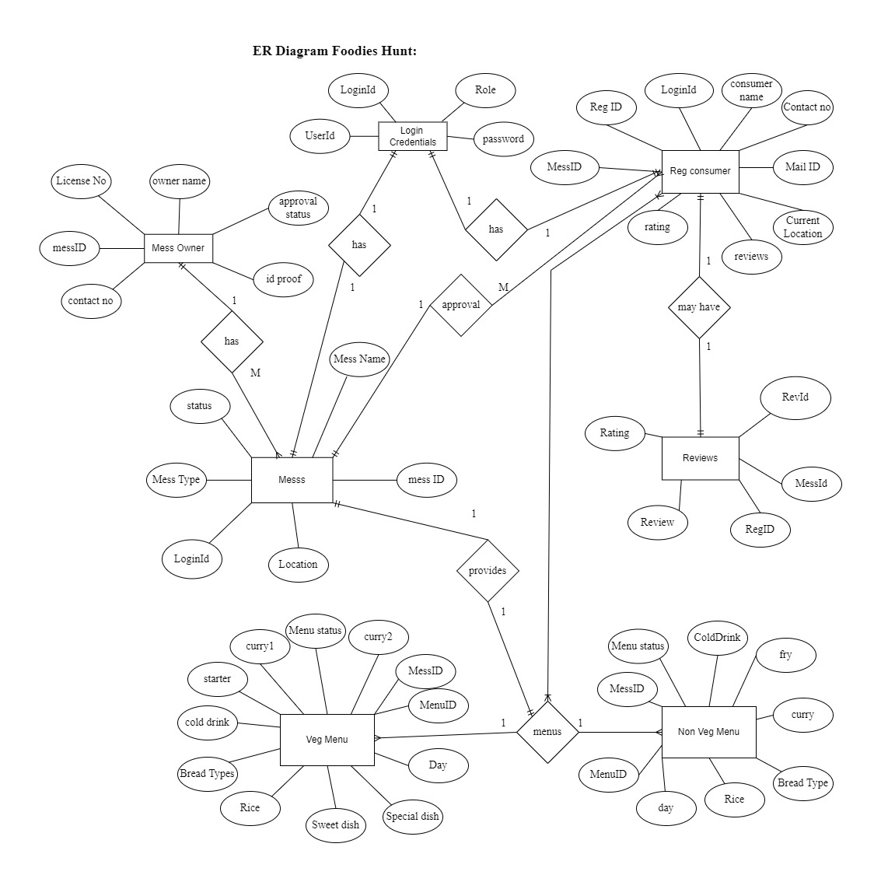

**E-R diagram shows database of Online Mess Service System**

**8. Snapshots:**

**8.1 Home Page:**

Following snapshot shows the Home page for Foodies Hunt

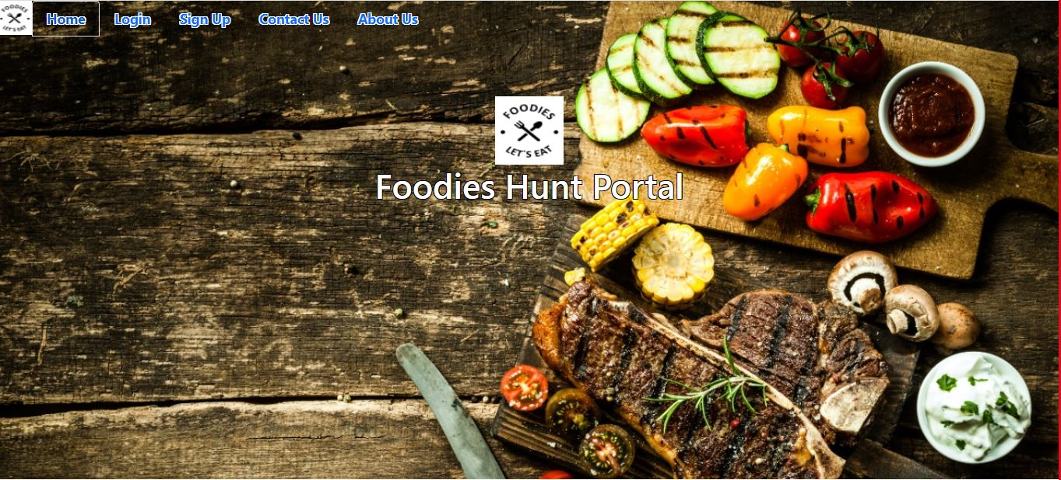

This page contains following controls

* Home
* Login
* Sign Up
* Contact Us
* About Us

**8.2 About Page**

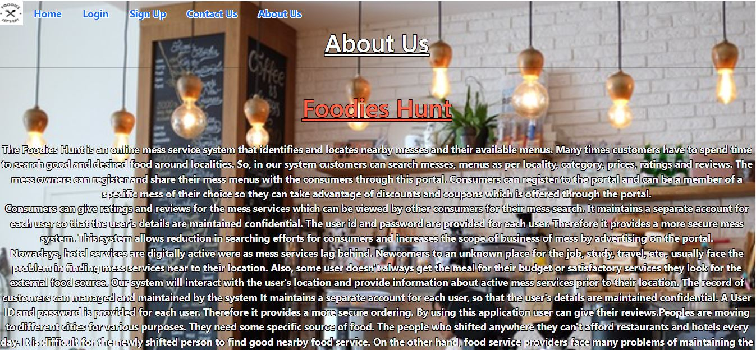

**Contact Page**

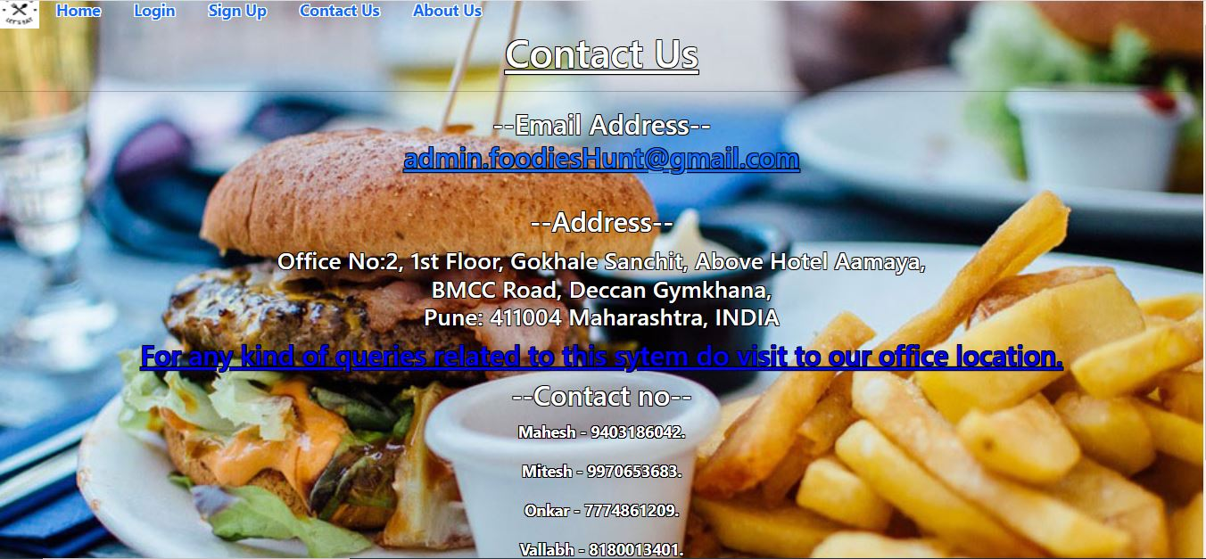

**8.3 Login Page**

Following snapshot shows the Login page for Foodies Hunt.

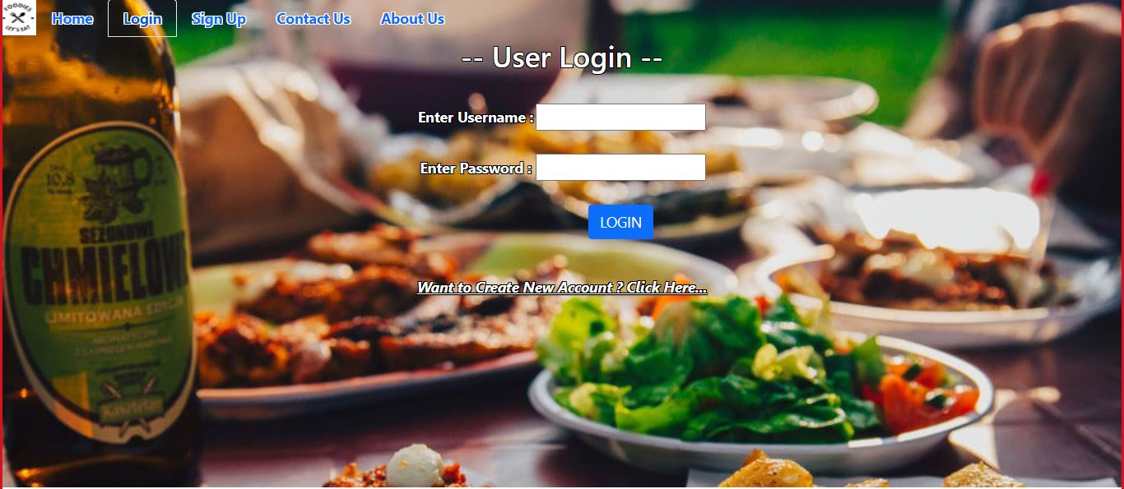

**8.4 Consumer Registration Page**

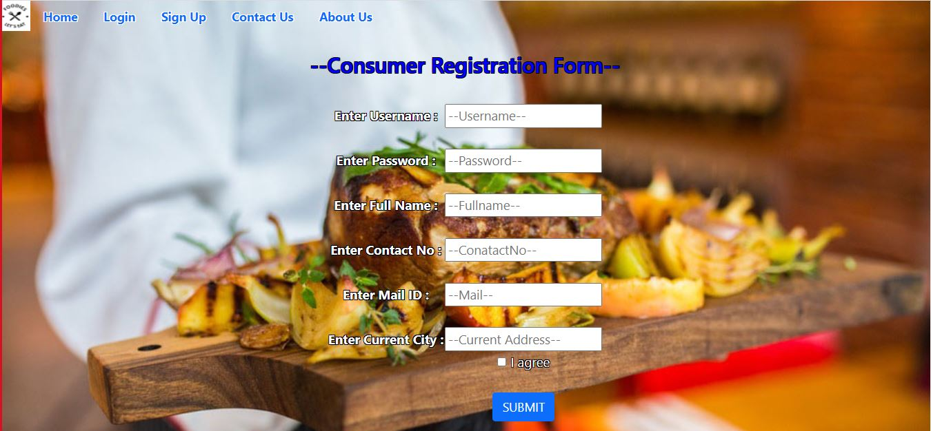

**8.5 Mess Owner Registration Page**

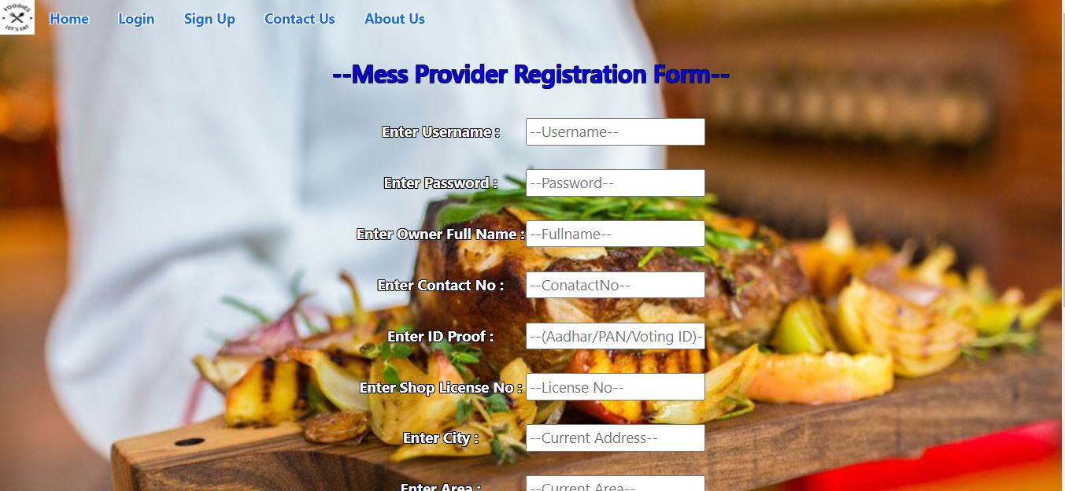

**8.6 Consumer Dashboard**

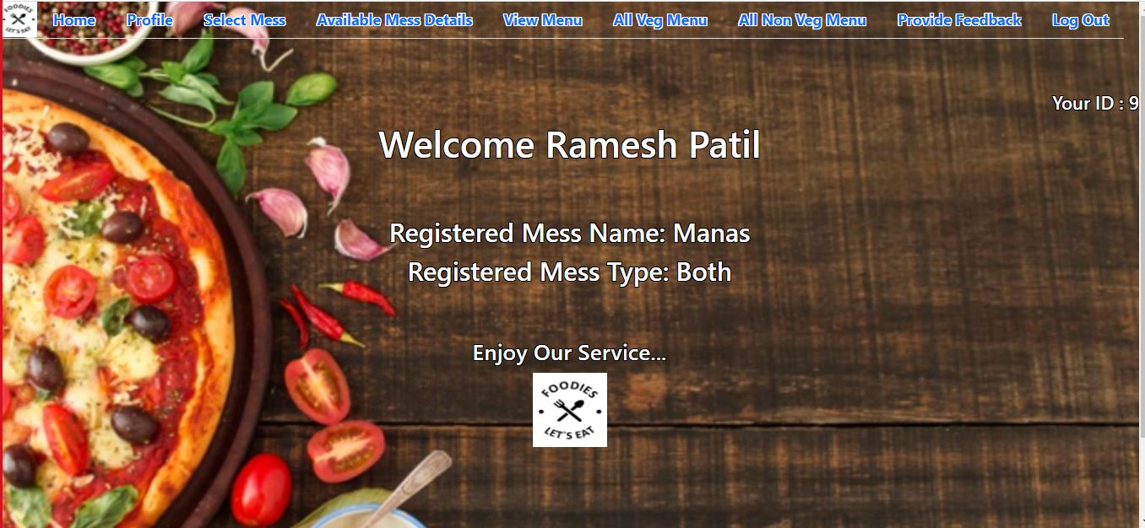

* 1. **Select Mess**

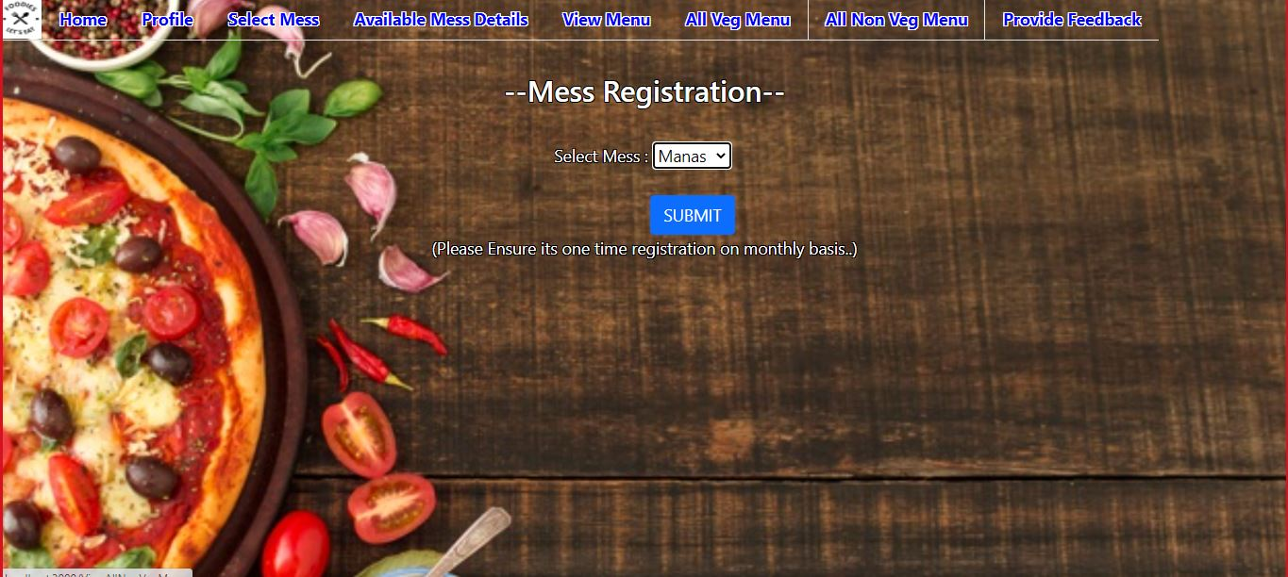

* 1. **Available Mess Details**

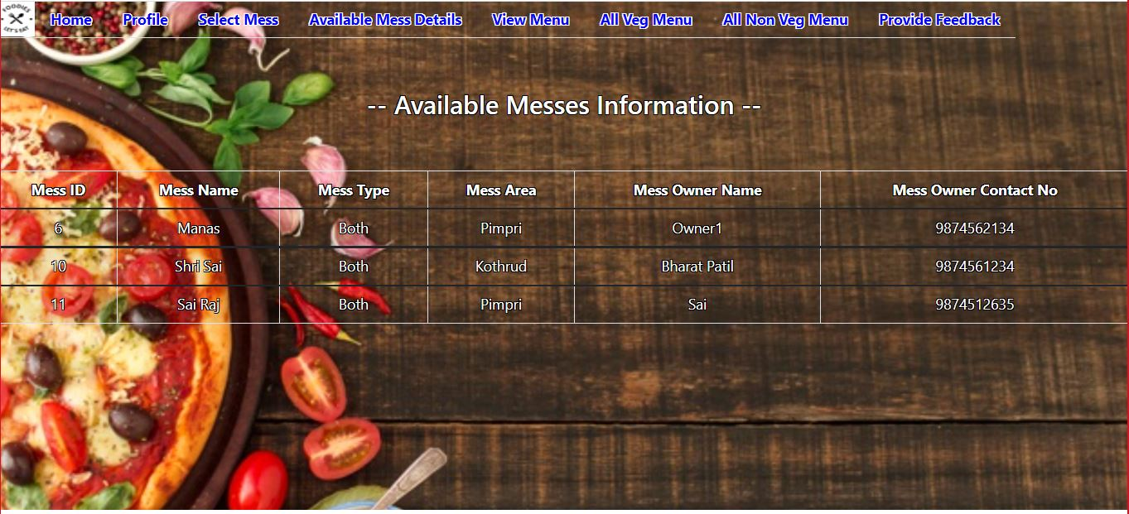

* 1. **View all menu (Registered Mess)**

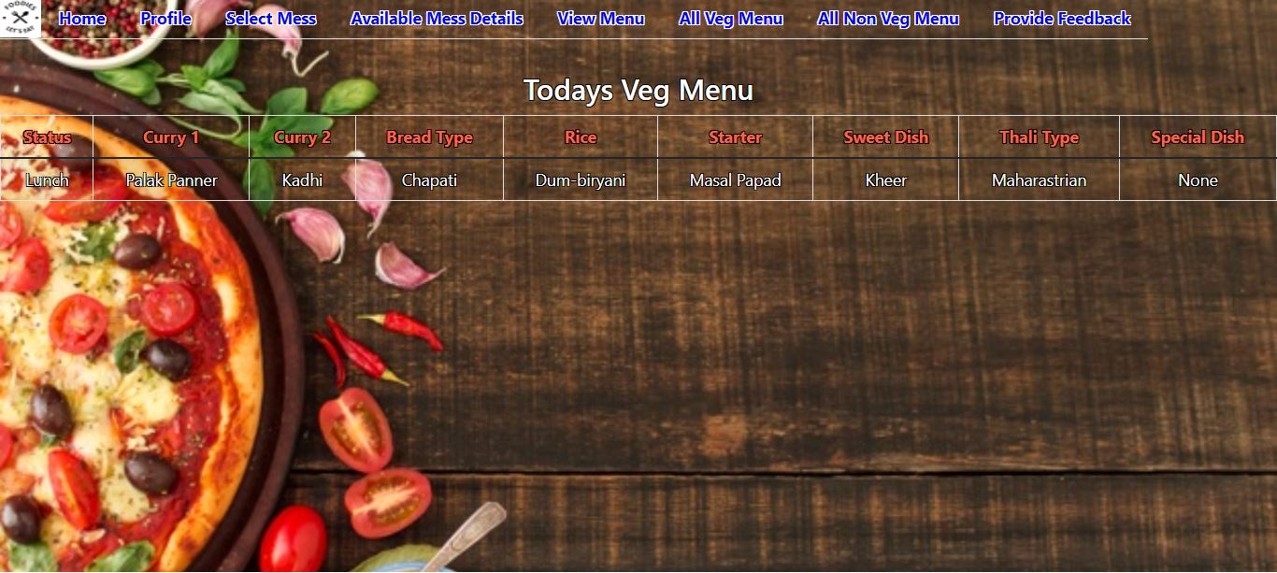

* 1. **View vegMenu (All Mess)**

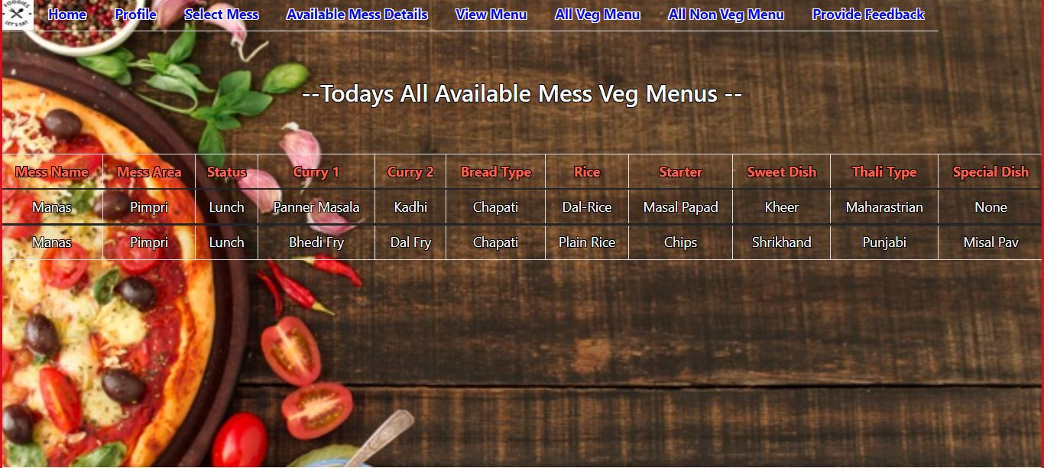

* 1. **View Non-Veg Menu (All Mess)**

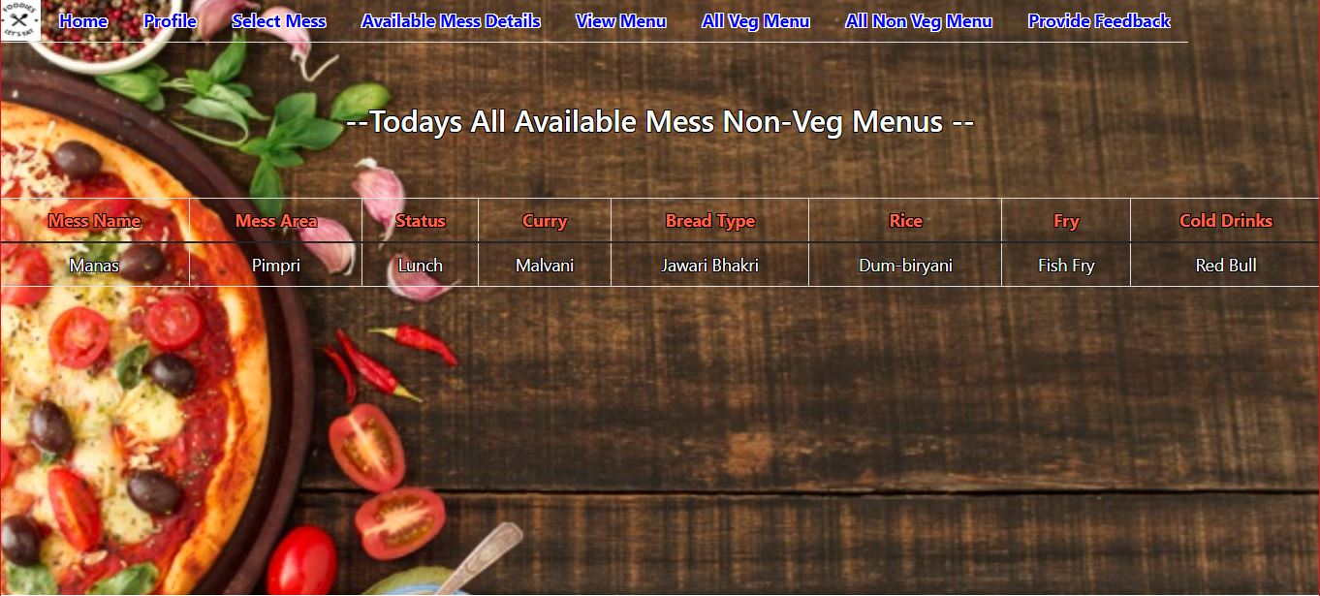

* 1. **Provide Feedback**

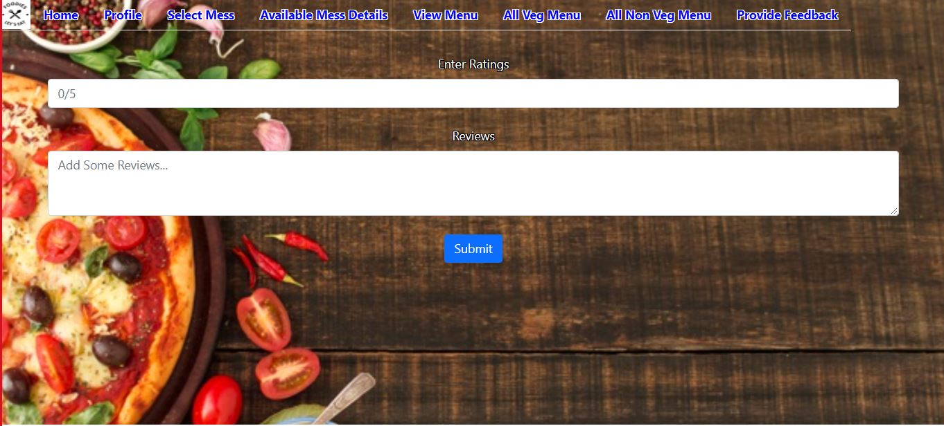

* 1. **Mess Dashboard (Provider)**

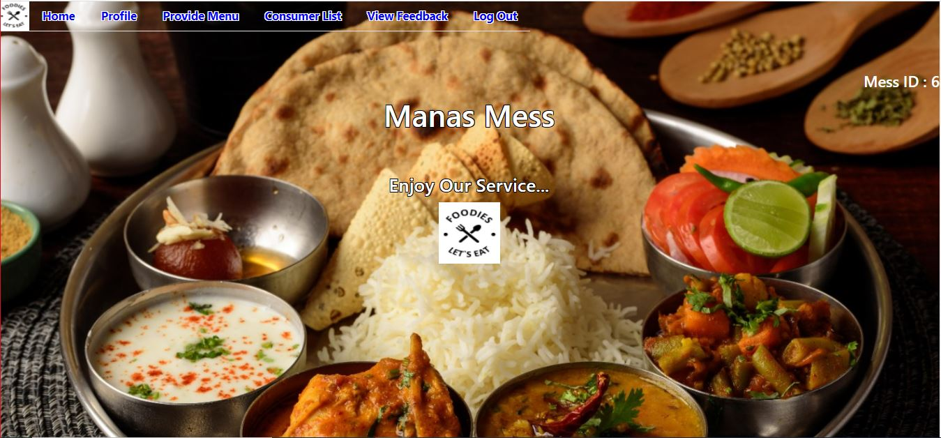

* 1. **Provide veg Menu**

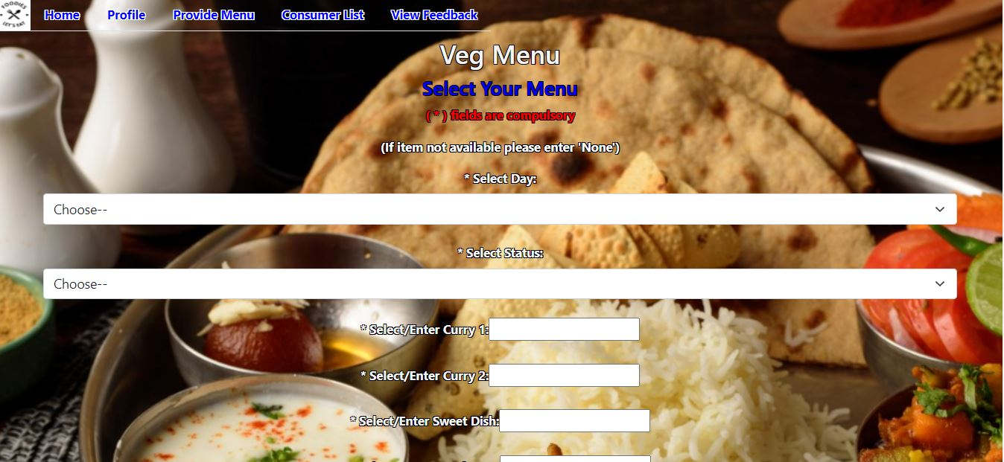

* 1. **Provide Non veg Menu**

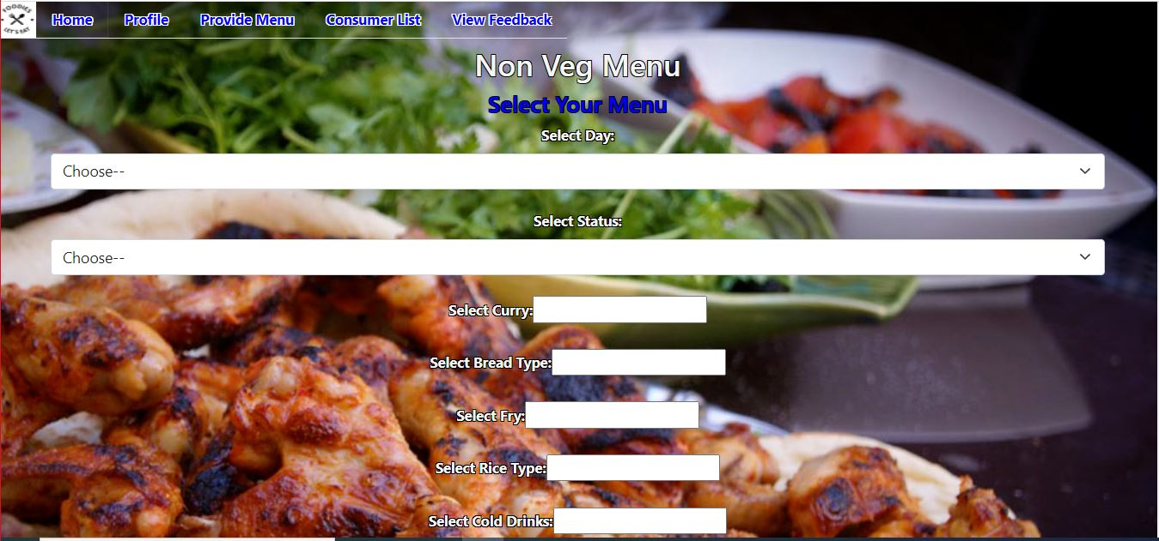

* 1. **Consumer List**

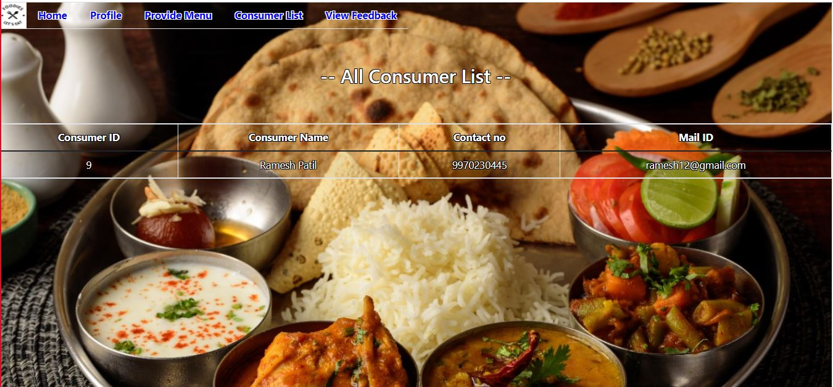

* 1. **View Feedback**

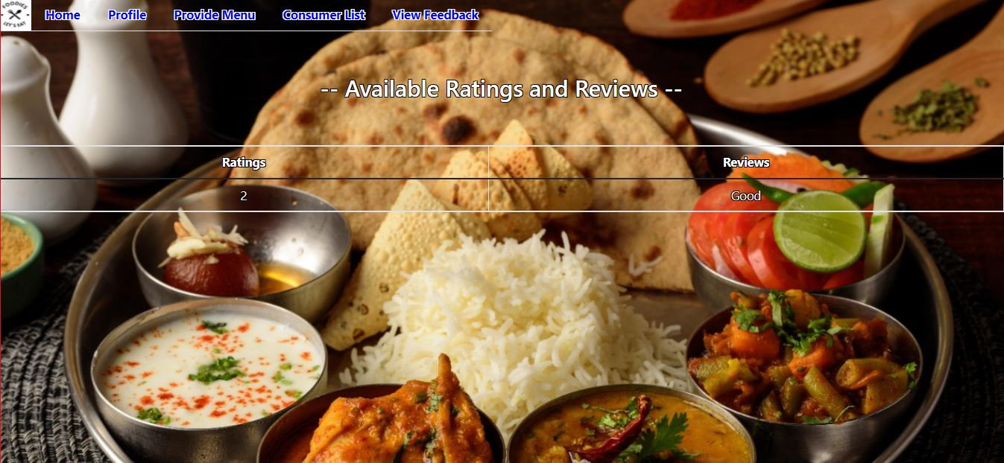

* 1. **Admin Page**



* 1. **Pending Mess Approval**

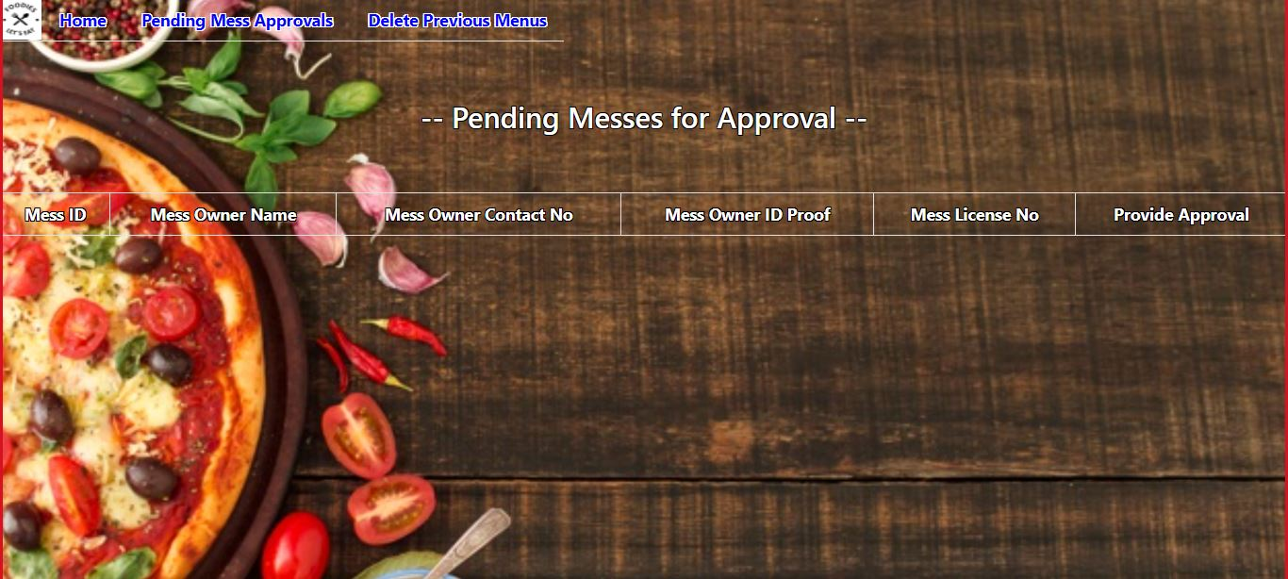

* 1. **Delete Previous Menu**

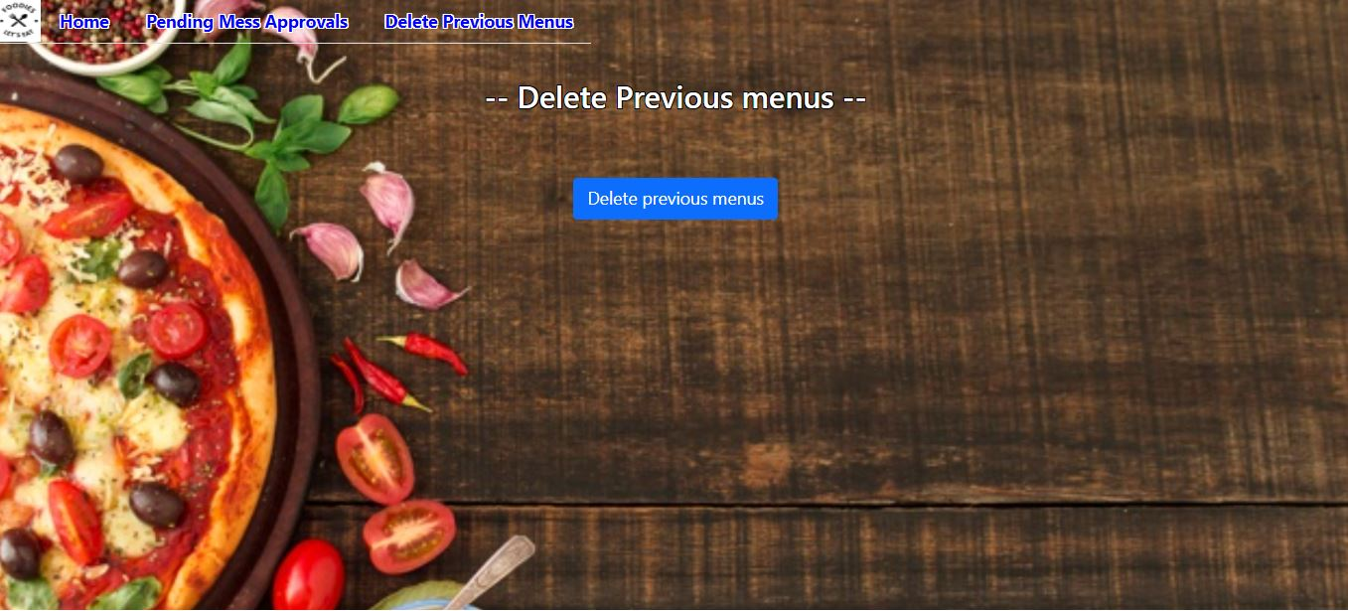

**9. CONCLUSION AND FUTURE SCOPE**

This project is building a platform which will help bachelors, students from various cities to communicate with various mess owners and to ease their searching efforts.

Our System provides a very user-friendly platform where Consumer can easily search the Mess, View Menu. Mess Owner will convey mess menu to consumers very efficiently, Mess Owner can view ratings and read feedback given by consumers to improve their service.

Foodies Hunt has very much potential to grow further and have many functionalities embedded like association with google map ,payment and billing system, Discount and offer management system.